Exp.No-3

3. Perform basic Image Handling and processing operations on the image
• Read an image in python and Convert an Image to show outline using Canny function.

Aim:
To detect the edges of an image using the Canny Edge Detection technique.

Procedure:
- Start the program.
- Import the OpenCV library.
- Read the input image.
- Convert the image to grayscale.
- Apply Canny Edge Detection.
- Display the original and edge images.
- Save the edge image.
- Stop the program.
Program:
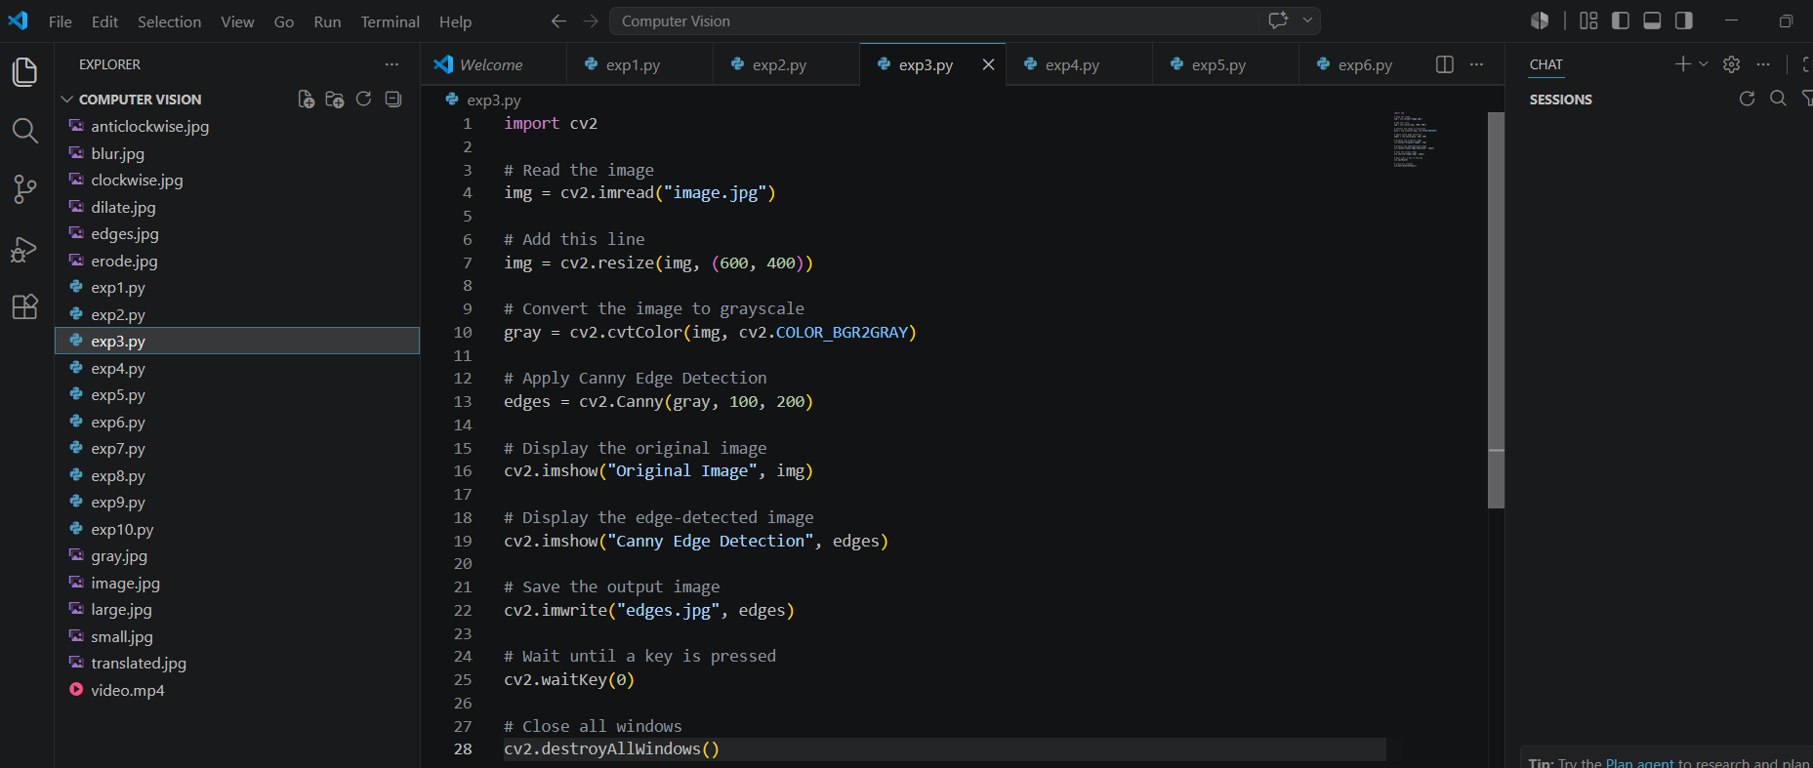

Input:


Output:
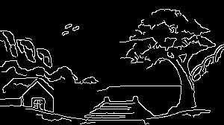

Result:
The edges of the input image were successfully detected and displayed.

